**Installation**

***Step 1:*** Create a new virtual environment  
conda create — name exampleenv

***Step 2:*** Activate your virtual environment  
conda activate exampleenv

***Step 3:*** Install Python  
conda install python==3.7.6

***Step 4:*** Install the latest version of Tensorflow  
conda install tensorflow

***Step 5:*** Create a new working directory and go into the folder.  
mkdir myWorkspace  
cd myWorkspace

***Step 6:*** Clone the pose estimation repository.

git clone <https://github.com/gsethi2409/tf-pose-estimation.git>

***Step 7:*** Enter the folder and install the requirements.

cd tf-pose-estimationpip install -r requirements.txt

***Step 8:*** Install [SWIG](http://www.swig.org/download.html)

conda install swig

***Step 9:*** Build C++ library for post-processing.

cd tf_pose/pafprocessswig -python -c++ pafprocess.i && python3 setup.py build_ext --inplace

***Step 10:***Install OpenCV.

pip install opencv-python

***Step 11:***Install *[tf-slim](https://github.com/adrianc-a/tf-slim)*library.

pip install git+https://github.com/adrianc-a/tf-slim.git@remove_contrib

***Step 12:***Download Tensorflow Graph File (pb file).

cd models/graph/cmubash download.shcd ../../..

***Step 13:***Run a quick test!

Python runworking.py --image==exampleimg.jpg

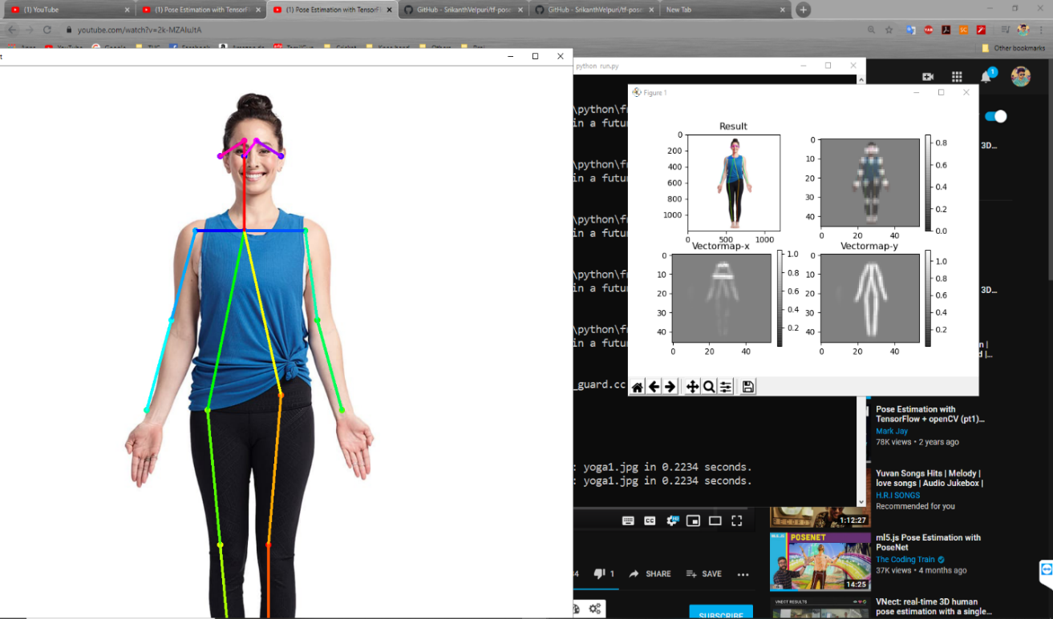

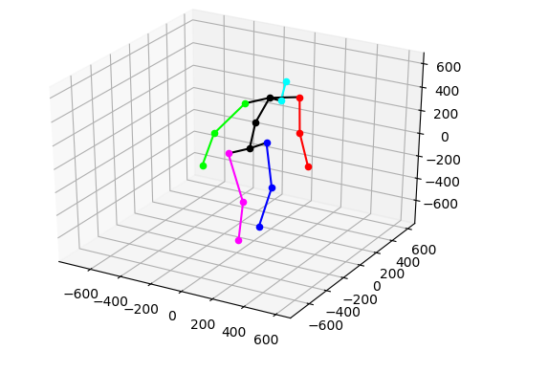

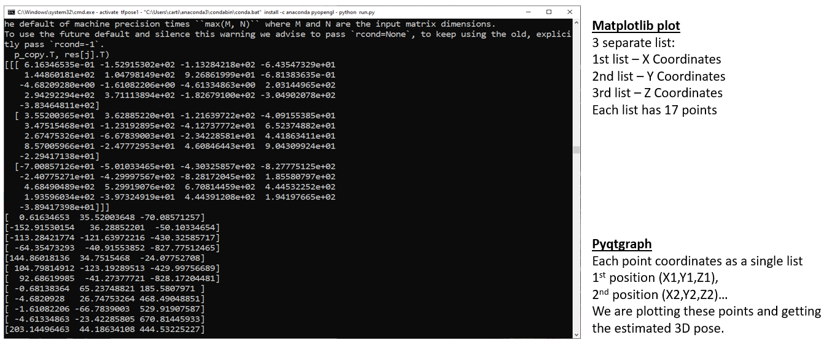

**Step 14:**Run a webcam test!

python testwebcam3D.py

